**Josh Brown, Dre Owens, Farrius Dean**

**3/4/23, CNE340**

**Christine Sutton**

**Final Project – Statement of Work**

Development Outline:

The goal of this program is to compare precipitation levels in the Pacific Northwest to carbon levels over time, and graph the data using PANDAS. We’re currently looking at different APIs and trying to compare their data sets, but so far we’ve added these to our list:

<https://openweathermap.org/api> (may not be free)

or:

<https://open-meteo.com/> (free, open source)

These are going to be the primary two we use unless we find significantly better data.

Execution:

Our program should be able to import weather data into a database and query the data for comparison as needed. The overall goal is to be able to predict rain levels in ten years from now, based on how much carbon is produced in the Pacific Northwest. If successful, we should be able to demonstrate a correlation between the two. We will conclude this project with a group presentation in late March.

Timeline:

3/1/23 – Start of project, coding and program design can begin

3/7/23 – Statement of Work completed and turned in

3/14/23 – Debugging of existing code and bug discussion

3/21/23 – Due date for deliverables

3/22/23 – Presentation date

**AUTHORIZATION**

**Date:** 11/20/2022

**Provider printed name:** Joshua Brown

**Provider signature:**

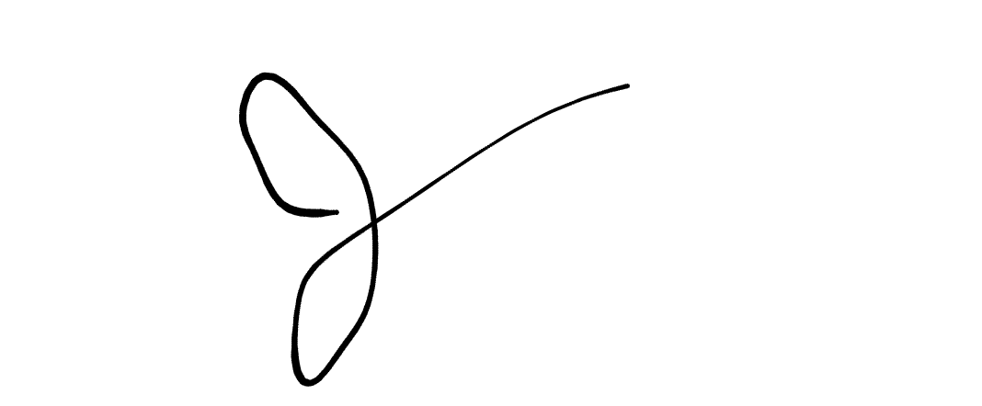

**Date:**

**Provider printed name:**

**Provider signature:**

**Date:**

**Provider printed name:**

**Provider signature:**